01)

02)

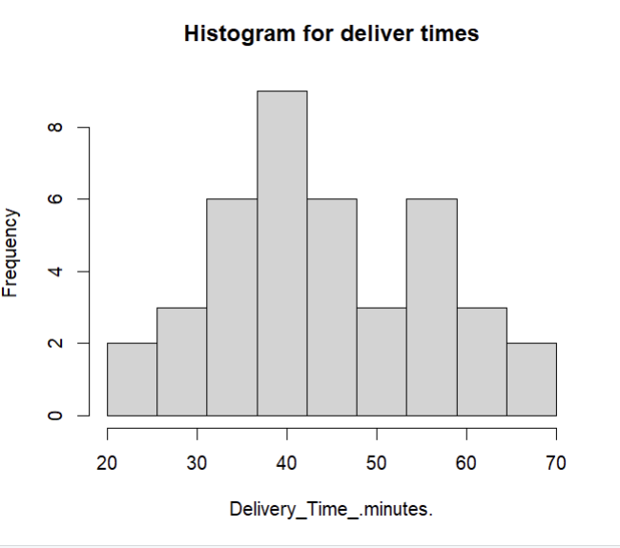

03)

The histogram shows a slightly right-skewed distribution, with a higher frequency of delivery times in the range of 30–50 minutes.

There are fewer observations than 60 minutes.

04)



